ClaimContact Widgets

Exercise 1: Configuration

Configure ClaimCenter to meet the following customer requirement from Acme Insurance.

1. This lesson depends upon the data model modifications made in the "Contact Roles" lab.

Requirement: Adding Interpreters Directly to Negotiations

Acme Insurance wants to be able to assign an interpreter to each negotiation.

1. Create a widget on the **Negotiation view/edit** screen that allows users to assign a contact to the negotiation that inherently has the role of interpreter. The widget should meet the following criteria:

* It appears below the **Negotiation Contact** field.
* It is labeled **Interpreter**.
* The dropdown lists only contacts that are of subtype **Person**.
* The picker menu allows only contacts of subtype **Person** to be created.

1. If you do not see your new interpreter virtual property within Studio, restart Studio.

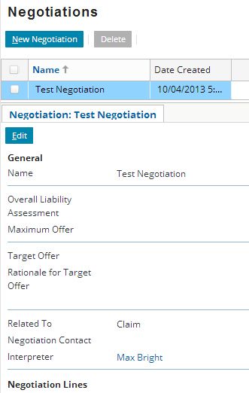

**Test Case**

When you have completed your configuration, run the following test cases:

1. Log on to ClaimCenter and navigate to a claim which has at least one person contact and one company contact. (If necessary, add a contact to an existing claim, such as adding an auto repair shop to an auto claim.) Create and save a negotiation on the claim. Verify that:

* The **Interpreter** widget is visible on the Negotiation detail screen when you view/edit the Negotiation.
* The dropdown lists persons (but not companies).

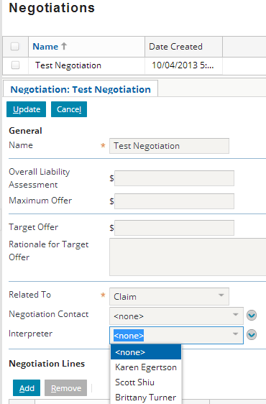

1. Create a new interpreter. Then, go to the **Parties Involved** screen and verify that the new interpreter is listed there with the role of interpreter.

